**CO452 Programming Concepts**

**PR1 Group Project**

Game Title: METAUNIVERSE

Authors**: Name: Marius Boncica Bucks New ID: 22045429**

**Name: Martin Konecky Buck New ID:**

GitHub Repository: [CW2-CO452/Game1 at main · UnicoAI/CW2-CO452 (github.com)](https://github.com/UnicoAI/CW2-CO452/tree/main/Game1)

GitHub WIKI: [METAUNIVERSE GAME CO452 CW2 · UnicoAI/CW2-CO452 Wiki (github.com)](https://github.com/UnicoAI/CW2-CO452/wiki/METAUNIVERSE-GAME-CO452-CW2)

Video Metauniverse Game Playing: <https://screencast-o-matic.com/watch/c0Vq2kVwKKW>

WEB PRESENTATION

<https://sway.office.com/GuGFPslhnNyFTSsG?ref=Link&loc=play>

|  |
| --- |
|  |
| [CO452 PROGRAMMING CONCEPTS](https://sway.office.com/GuGFPslhnNyFTSsG?ref=email&loc=play) |
| AUTHORS: Name: Marius Boncica Bucks New ID: 22045429 |
| |  | | --- | | [Go to this Sway](https://sway.office.com/GuGFPslhnNyFTSsG?ref=email&loc=play) | |

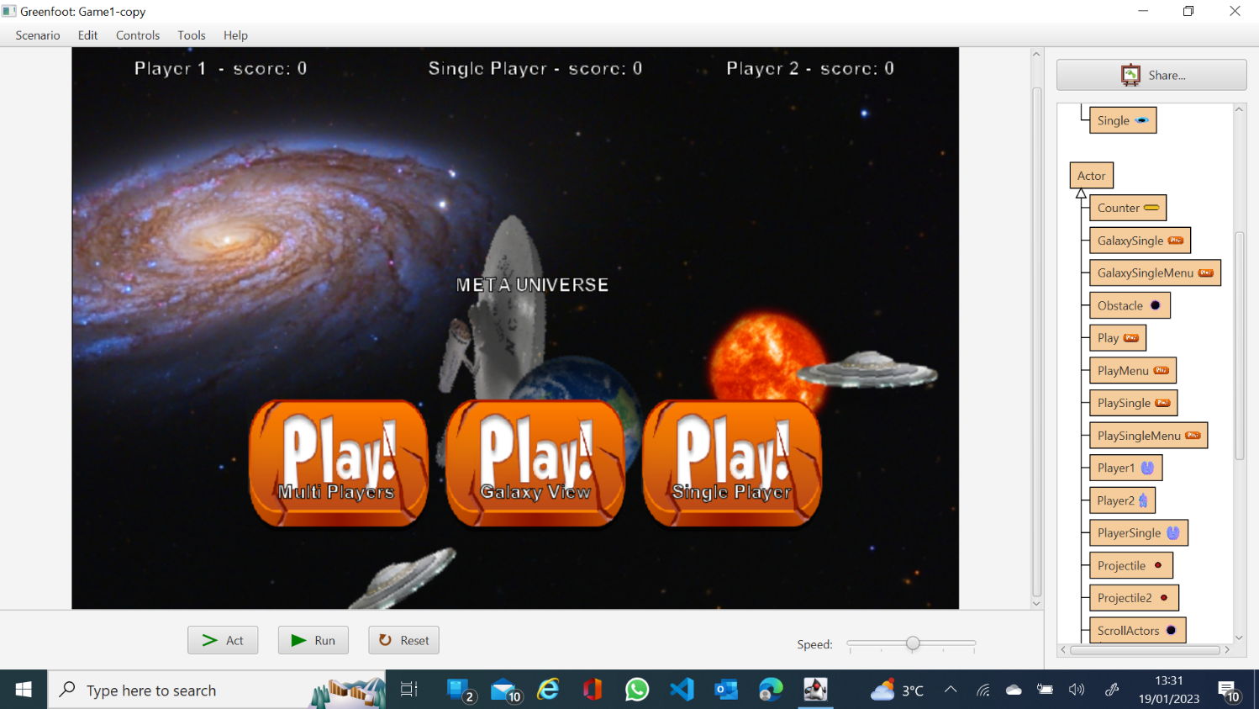

Contents

Authors**:** 1

Game Title 1

Introduction 1

Design Consideration 1

Mapping 1

Structure 1

World Class 1

Actors 1

Players Classes 1

Enemies and Other Objects 1

Counter and Speed 1

Development of the game and Problem Solving 1

Demonstration of Gameplay and Testing 1

Video Metauniverse 1

Evaluation 1

# Game Title

**METAUNIVERSE**

**Contributors: *Marius Boncica and Martin Konecky***

**PR1 Group Project – CO452 Programming Concepts**

**Video Metauniverse Game Playing:**

<https://screencast-o-matic.com/watch/c0Vq2kVwKKW>

# Introduction

**METAUNIVERSE** Game is about protecting the earth from the aliens and approaching steroids.

It is a 2D green foot game, but we animated the objects to approach a 3D visual aspect.

Game contains three levels:

***1 Galaxy View:***

***2 Single Player***

***3 Multiplayer***

User will need to shoot aliens and collect boosters to increase movement speed.

A certain number of points are necessary to destroy the approaching asteroid.

We use Simple timer to limit the time playing to 1 minute.

# Design Consideration

## **Mapping**

At the start at the game, we design a map of the space and being a group project, we decide to contain all the objects created to design the map into an array and create a map using index of array to add objects on screen map.

We start collecting images and create new animations in photoshop.

We used of the import of the Gif Image class to scale the gif images and used them frame by frame.

## **Structure**

### ***World Class***

The game contains **7 Worlds classes**:

Menu class was created for start game menu and contains button (objects) that redirect on click event user to other worlds classes as:

*Galaxy Class*—contains instruction and button to redirect to WorldLevel1 Class which is a single player galaxy navigation and aliens shooting game

*Galaxy2ndLevel Class*-- contains instruction and button to redirect to Single Class which is a single player Asteroid removal target game.

*Galaxy3rdLevel Class--* contains instruction and button to redirect to World Class which is a multiplayer player Asteroid removal target game.

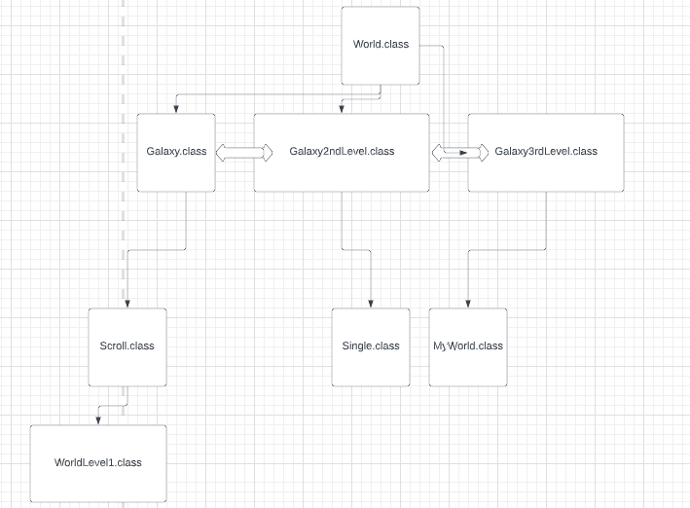

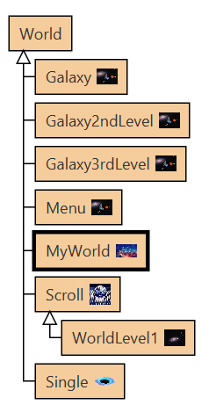

### **Actors**

After creating the map, we create the actors as players, enemies and objects floating. 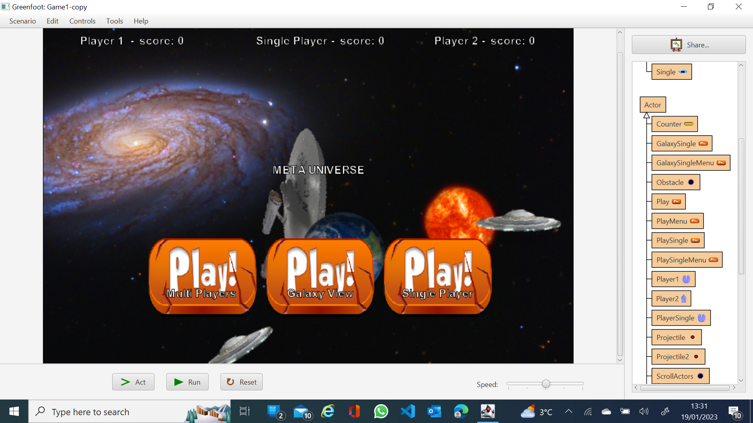

### **Players Classes**

*Player1 class*

*Player2 class*

*Player Single class*

*Plane class extends Scroll Actors class.*

All players classes contain Constructor methods to scale image, methods to shoot (by creating objects on click event or key pressed event), removal of other objects if are touching and methods to increase/ decrease score if are touching specific objects. 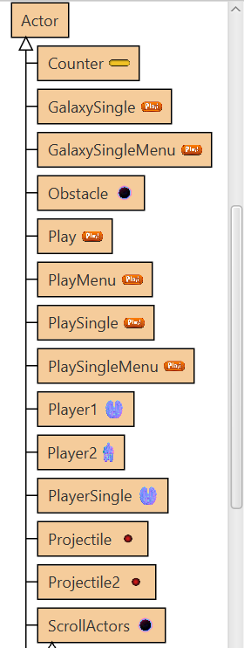

### **Enemies and Other Objects**

Enemy class – contains methods to remove object if is touching instances of projectile. Class or if are touching player. Class

Projectile classes that contain methods to remove at edge or when touching enemies

Sun, Earth, Asteroid, Step1 classes are created to populate the map and touching behaviours with player classes or projectile classes are inserted

Prize, speed Booster classes were created to give opportunity to the player to collect points or to increase speed if are touching or shooting them.

### **Counter and Speed**

We use counter class to keep record of the points earn and we create text speed record menu for each player.

They are updating using methods described in players classes.

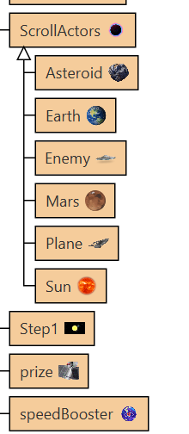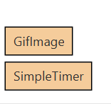

# Development of the game and Problem Solving

During the development and evaluating the game processes we encounter some issues with the Gif Images creating a java heap memory space error.

Problem was solved by using PNG images and create a method to turn and rotate and speed the image and achieve the look alike 3D model.

We add extra functionality to the menu by creating additional classes for each level that will inform user about instructions and control keys.

# Demonstration of Gameplay and Testing

## **Video Metauniverse**

We record our screen while playing all 3 levels of the game and the demonstration can be viewed at this link:

**Video Metauniverse Game Playing:**

<https://screencast-o-matic.com/watch/c0Vq2kVwKKW>

We took screenshots of the game to demonstrate that the gamed passed the testing and is fully functional.

**Menu Enter World**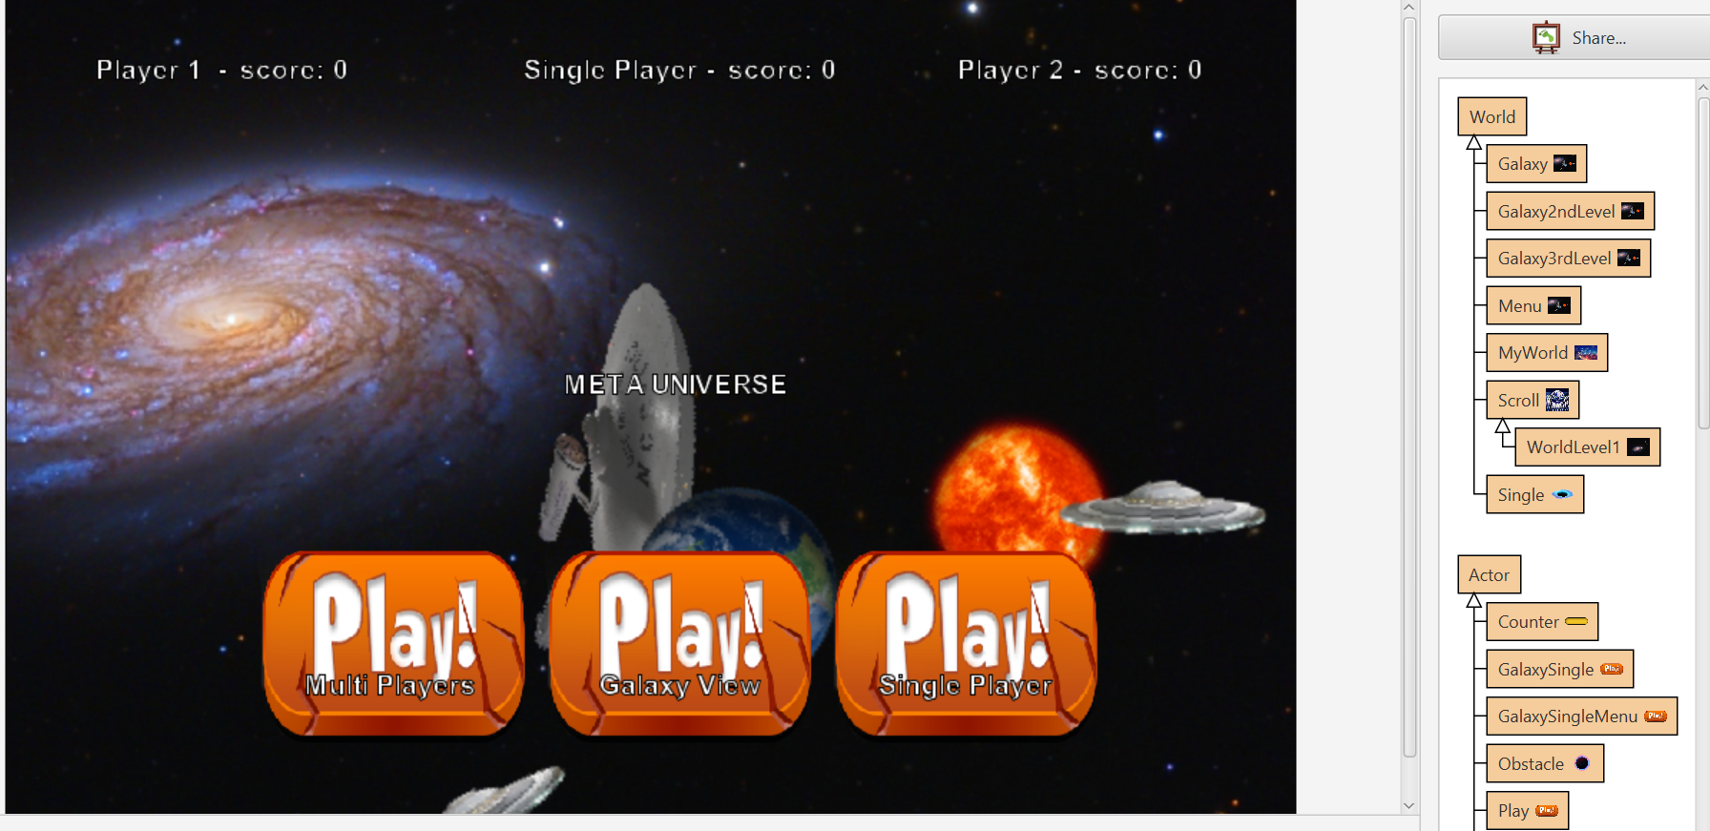

**Galaxy view intro**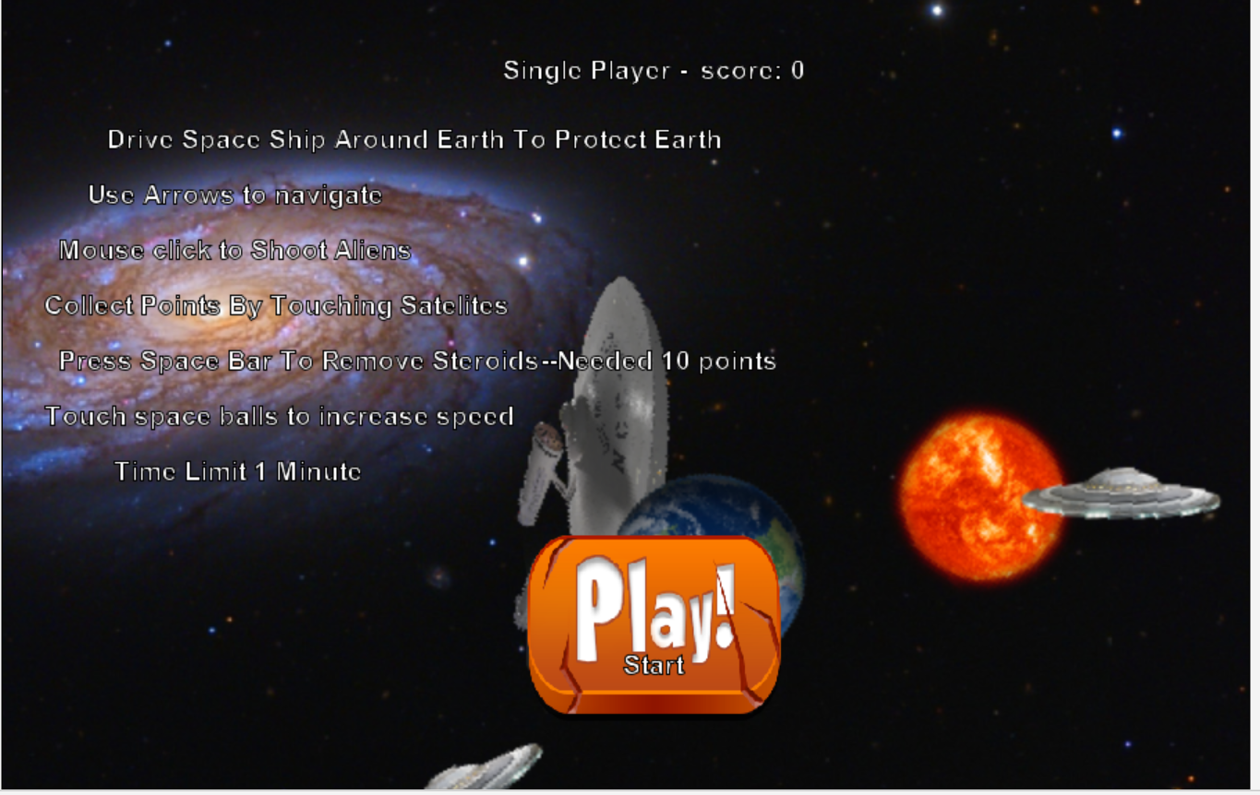

**Play**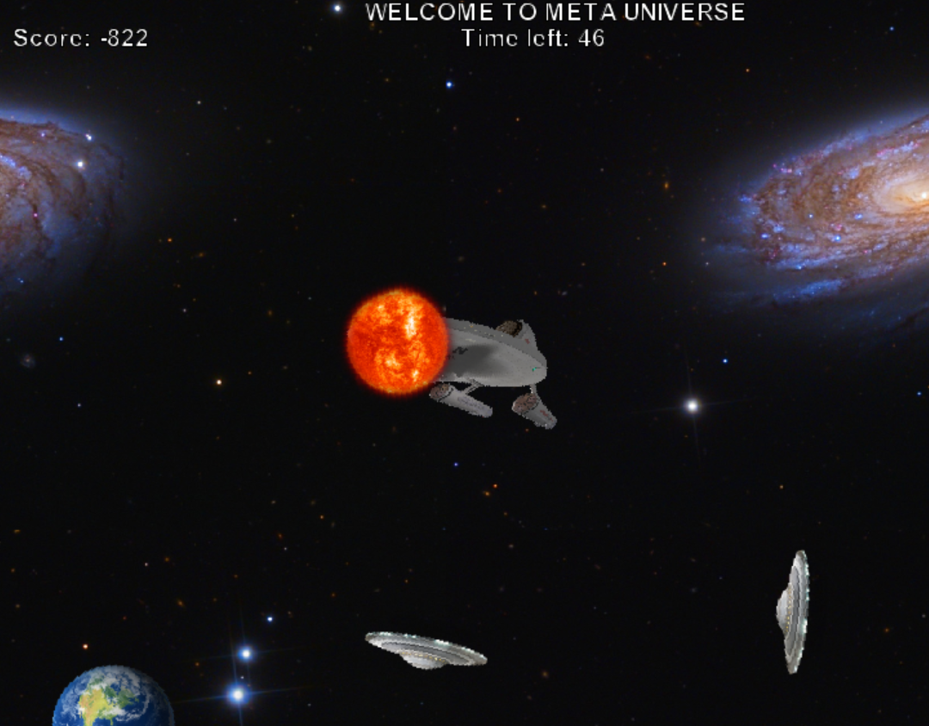

**Single Player Intro**

**Play**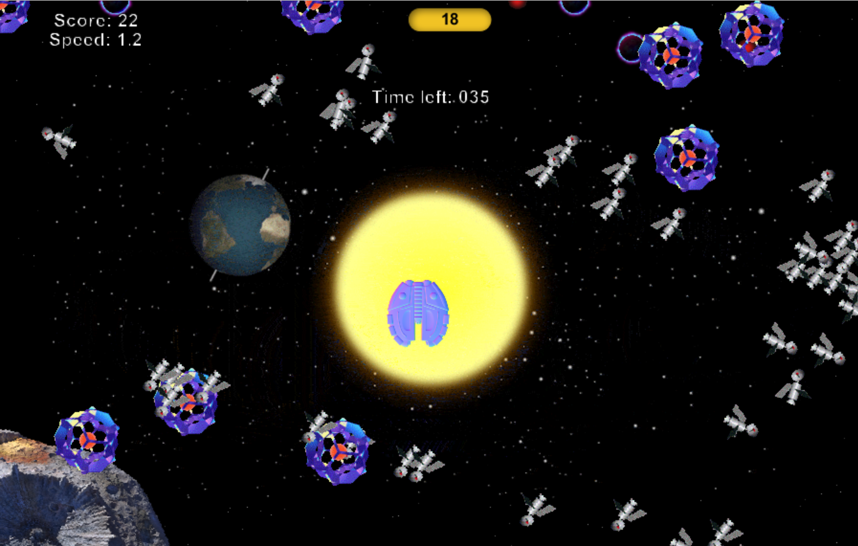

**Multiplayer Intro**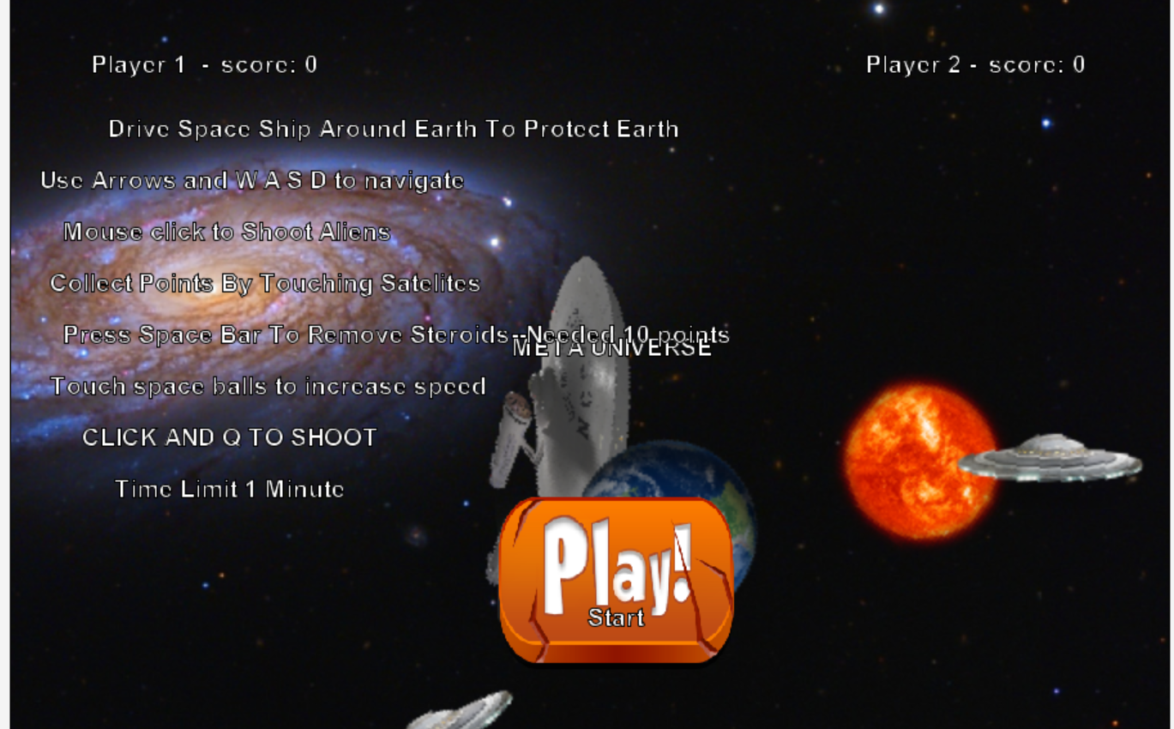

**Play**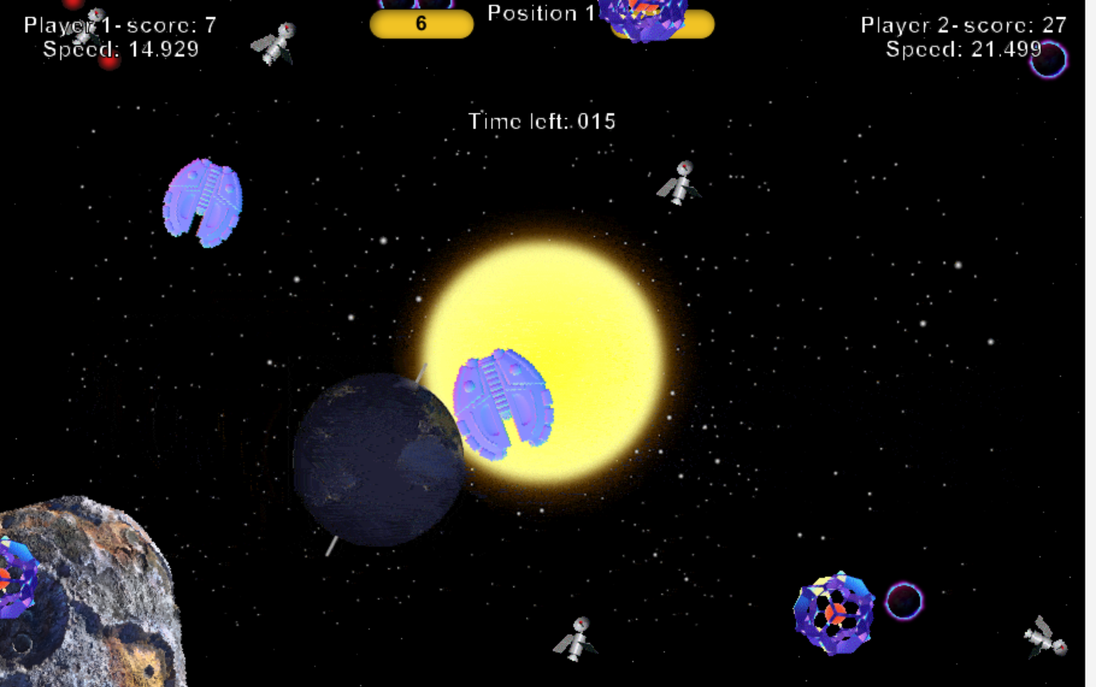

# Evaluation

The **Metauniverse** Game project was a challenging task because we had to develop the game for the 1st time using green foot and to create a game that respect all members ideas.

It was challenging but we both enjoyed the journey to the end of it even if involved a lot of research about Green foot and learning how to use java and use pre made green foot methods inside our classes.

More likely there are thinks that we can improve but that will need us to gain more experience coding in green foot and discover different methods and effects that we can create by spending more time on testing code variables.